**Student Score Calculator**

**REACT**

Vaishnavi

26/7/2025

This project is a simple React application that displays student details and calculates their performance percentage based on total marks and a goal. It demonstrates the use of functional components and CSS styling for a clean UI.

**Objective:**

* To create a functional component that calculates a student’s score.
* To apply custom styles using an external CSS file.
* To practice JSX syntax and basic arithmetic operations in React.

**Implementation:**

**Step 1: Create a React App**



**Step 2: Create Component and CSS File**

Inside the src/Components/ folder:

**CalculateScore.js**

import React from 'react';

import '../Stylesheets/mystyle.css';

function CalculateScore({ name, school, total, goal }) {

const average = total / goal;

return (

<div className="score-container">

<h2>Student Score Details</h2>

<p><strong>Name:</strong> {name}</p>

<p><strong>School:</strong> {school}</p>

<p><strong>Total Marks:</strong> {total}</p>

<p><strong>Goal:</strong> {goal}</p>

<p><strong>Average Score:</strong> {average}</p>

</div>

);

}

export default CalculateScore;

**mystyle.css**

.score-container {

background-color: #f0f8ff;

border: 2px solid #333;

border-radius: 10px;

width: 350px;

font-family: Arial, sans-serif;

box-shadow: 0 4px 6px rgba(0, 0, 0, 0.2);

}.score-container h2 {

text-align: center;

color: #2c3e50;

}.score-container p {

font-size: 18px;

margin: 10px 0;}

**Step 3: Use the Component in App.js**

import React from 'react';

import CalculateScore from './Components/CalculateScore';

function App() {

return (

<div className="App">

<h1>Student Management Portal - Score Calculator</h1>

<CalculateScore name="John Doe" school="ABC High School" total={450} goal={5} />

</div>

);

}

export default App;

**Step 4: Run the App**



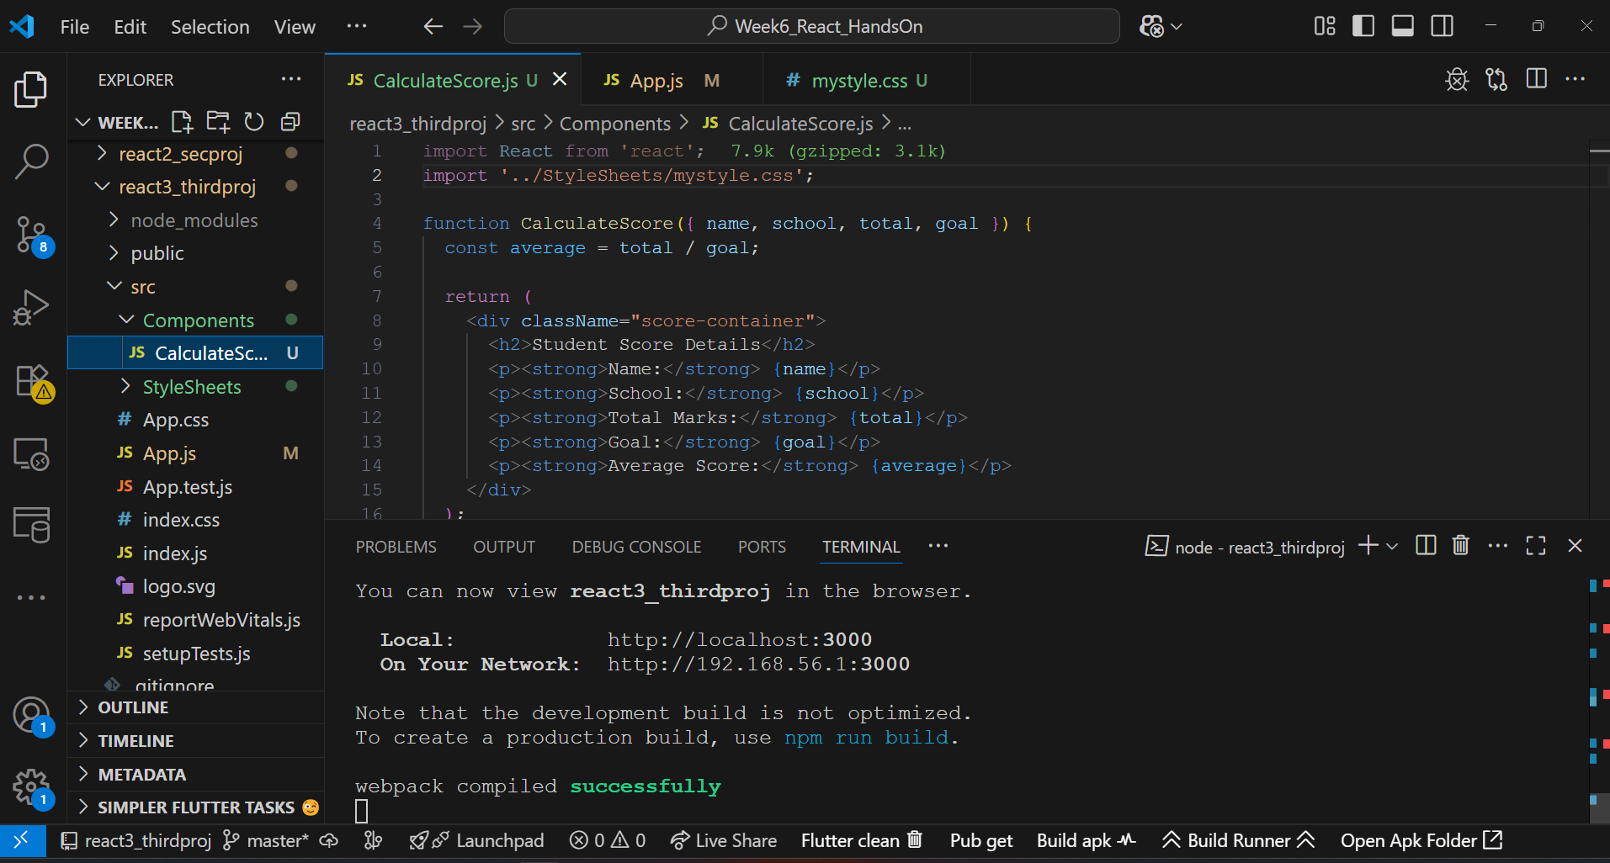

**Output:**

